**COGNIZANT DIGITAL NURTURE PROGRAM 4.0**

**JAVA FSE DEEP SKILLING**

**SUPERSET ID : 6391159**

**NAME : SATHYA SHREE R**

**CLASS : ECE C**

**REG NO : 727822TUEC207**

**WEEK 6 HANDS ON EXERCISE – REACT**

**Exercise 1 : Run A React Application**

**PROBLEM STATEMENT :**

Create a new React Application with the name “myfirstreact”, Run the application to print “welcome to the first session of React” as heading of that page.

**CODE :**

**App.js**

import React from 'react';

function App() {

  return <h1> COGNIZANT <br></br>Welcome to the first session of React</h1>;

}

export default App;

**index.js**

import React from 'react';

import { createRoot } from 'react-dom/client';

import App from './App';

const root = createRoot(document.getElementById('root'));

root.render(<App />);

**.babelrc**

{

  "presets": ["@babel/preset-env", "@babel/preset-react"]

}

**index.html**

<!DOCTYPE html>

<html lang="en">

  <head>

    <meta charset="UTF-8" />

    <meta name="viewport" content="width=device-width, initial-scale=1.0" />

    <title>My First React</title>

  </head>

  <body>

    <div id="root"></div>

    <script src="./src/index.js"></script>

  </body>

</html>

**Package.json**

{

  "name": "myfirstreact",

  "version": "1.0.0",

  "main": "index.js",

  "license": "MIT",

  "scripts": {

    "start": "parcel index.html --open"

  },

  "dependencies": {

    "react": "^18.3.1",

    "react-dom": "^18.3.1"

  },

  "devDependencies": {

    "parcel": "^2.12.0",

    "@babel/core": "^7.22.0",

    "@babel/preset-env": "^7.22.0",

    "@babel/preset-react": "^7.22.0"

  }

}

**OUTPUT :**

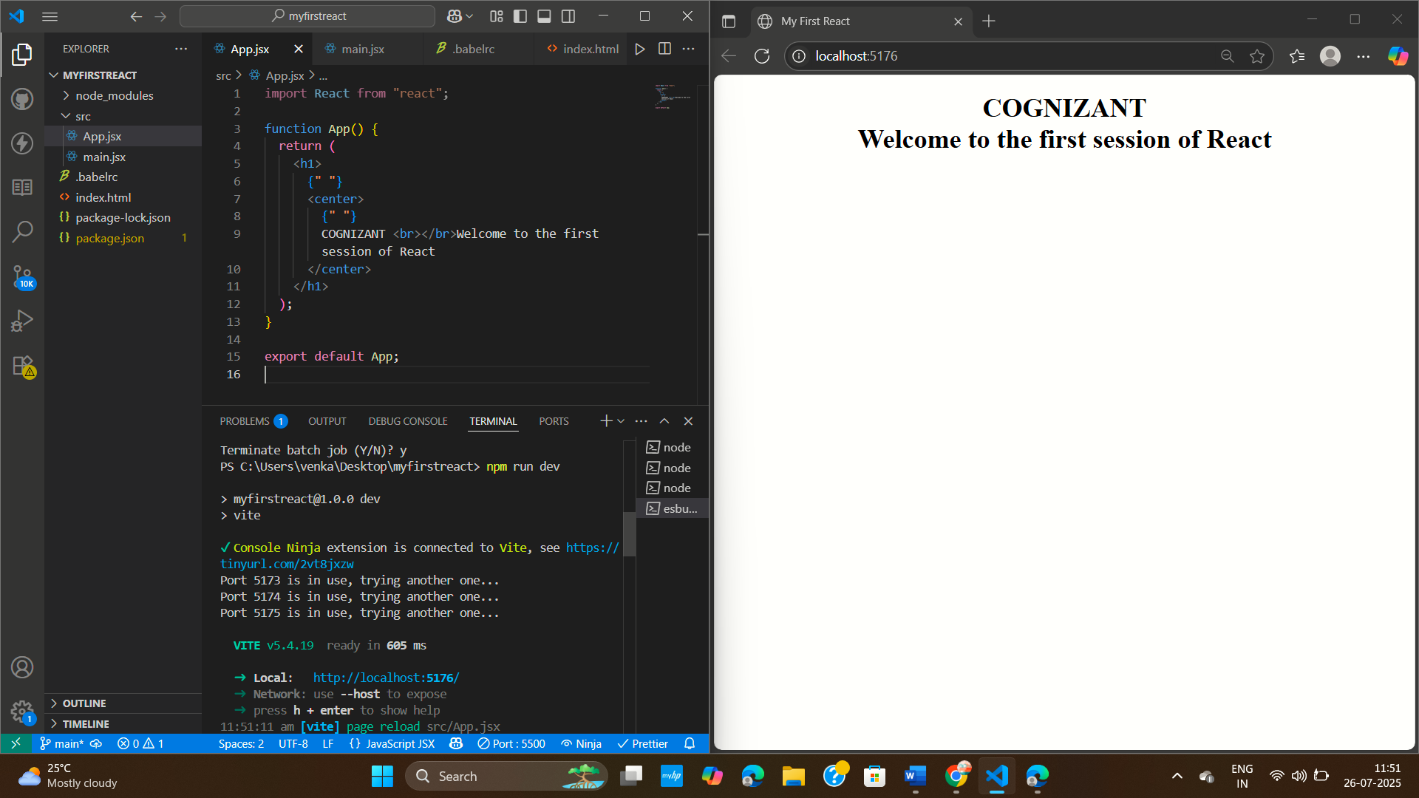

**Exercise 2 : Student Management Portal**

**PROBLEM STATEMENT :**

Create a react app for Student Management Portal named StudentApp and create a component named Home which will display the Message “Welcome to the Home page of Student Management Portal”. Create another component named About and display the Message “Welcome to the About page of the Student Management Portal”. Create a third component named Contact and display the Message “Welcome to the Contact page of the Student Management Portal”. Call all the three components.

**CODE :**

**index.html**

<!DOCTYPE html>

<html lang="en">

  <head>

    <meta charset="utf-8" />

    <meta name="viewport" content="width=device-width, initial-scale=1" />

    <title>StudentApp</title>

  </head>

  <body>

    <div id="root"></div>

  </body>

</html>

**About.js**

import React from 'react';

function About() {

  return (

    <div>

      <h2>Welcome to the About page of the Student Management Portal</h2>

    </div>

  );

}

export default About;

**Contact.js**

import React from 'react';

function Contact() {

  return (

    <div>

      <h2>Welcome to the Contact page of the Student Management Portal</h2>

    </div>

  );

}

export default Contact;

**Home.js**

import React, { Component } from 'react';

class Home extends Component {

  render() {

    return (

      <div>

        <h2><center>COGNIZANT</center><br>

        </br>Welcome to the Home page of Student Management Portal</h2>

      </div>

    );

  }

}

export default Home;

**App.js**

import React from 'react';

import './App.css';

import Home from './Components/Home';

import About from './Components/About';

import Contact from './Components/Contact';

function App() {

  return (

    <div className="App">

      <Home />

      <About />

      <Contact />

    </div>

  );

}

export default App;

**index.js**

import React from 'react';

import ReactDOM from 'react-dom/client';

import './index.css';

import App from './App';

const root = ReactDOM.createRoot(document.getElementById('root'));

root.render(

  <React.StrictMode>

    <App />

  </React.StrictMode>

);

**package.json**

{

  "name": "studentapp",

  "version": "1.0.0",

  "private": true,

  "dependencies": {

    "react": "^18.0.0",

    "react-dom": "^18.0.0",

    "react-scripts": "5.0.1"

  },

  "scripts": {

    "start": "react-scripts start",

    "build": "react-scripts build",

    "test": "react-scripts test",

    "eject": "react-scripts eject"

  },

  "browserslist": {

    "production": [

      ">0.2%",

      "not dead",

      "not op_mini all"

    ],

    "development": [

      "last 1 chrome version",

      "last 1 firefox version",

      "last 1 safari version"

    ]

  }

}

**OUTPUT :**

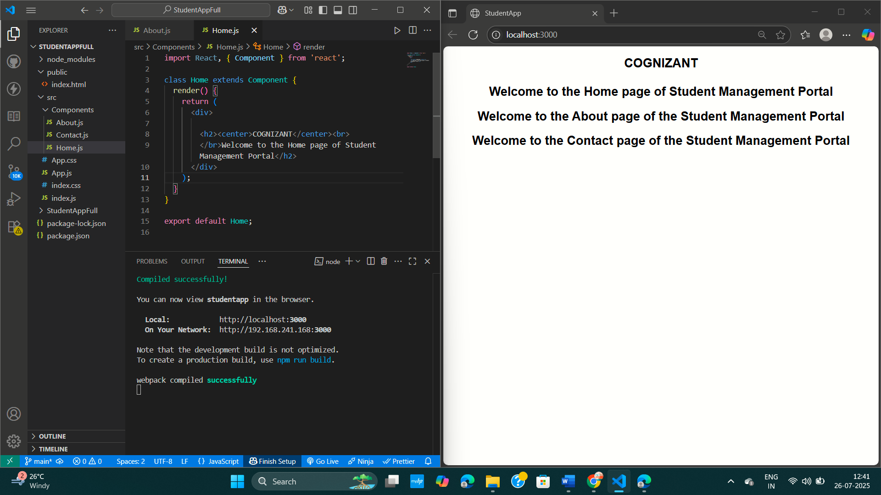

**Exercise 3 : Student Management Portal - CalculateScore**

**PROBLEM STATEMENT :**

Create a react app for Student Management Portal named scorecalculatorapp and create a function component named “CalculateScore” which will accept Name, School, Total and goal in order to calculate the average score of a student and display the same.

**CODE :**

**CalculateScore.jsx**

import React from 'react'

import '../Stylesheets/mystyle.css'

function CalculateScore({ name, school, total, goal }) {

  const average = (total / goal).toFixed(2)

  return (

    <div className="score-container">

      <h2>Student Score Calculator</h2>

      <p><strong>Name:</strong> {name}</p>

      <p><strong>School:</strong> {school}</p>

      <p><strong>Total Marks:</strong> {total}</p>

      <p><strong>Goal:</strong> {goal}</p>

      <h3>Average Score: {average}</h3>

    </div>

  )

}

export default CalculateScore

**mystyle.css**

.score-container {

  background-color: #f4f4f4;

  border: 2px solid #333;

  padding: 20px;

  margin: 20px auto;

  width: 300px;

  text-align: center;

  border-radius: 10px;

  font-family: Arial, sans-serif;

}

.score-container h2 {

  color: #e53e3e;

}

.score-container h3 {

  color: green;

}

**App.css**

.App {

  display: flex;

  justify-content: center;

  align-items: center;

  min-height: 100vh;

}

**App.jsx**

import React from 'react'

import './App.css'

import CalculateScore from './Components/CalculateScore.jsx'

function App() {

  return (

    <div className="App">

      <CalculateScore name="John Doe" school="ABC High School" total={450} goal={500} />

    </div>

  )

}

export default App

**index.css**

body {

  margin: 0;

  font-family: Arial, sans-serif;

  background: #f9f9f9;

}

**main.jsx**

import React from 'react'

import ReactDOM from 'react-dom/client'

import App from './App.jsx'

import './index.css'

ReactDOM.createRoot(document.getElementById('root')).render(

  <React.StrictMode>

    <App />

  </React.StrictMode>,

)

**index.html**

<!DOCTYPE html>

<html lang="en">

  <head>

    <meta charset="UTF-8" />

    <meta name="viewport" content="width=device-width, initial-scale=1.0" />

    <title>Score Calculator App</title>

  </head>

  <body>

    <div id="root"></div>

    <script type="module" src="/src/main.jsx"></script>

  </body>

</html>

**package.json**

{

  "name": "scorecalculatorapp",

  "private": true,

  "version": "0.0.0",

  "type": "module",

  "scripts": {

    "dev": "vite",

    "build": "vite build",

    "preview": "vite preview"

  },

  "dependencies": {

    "react": "^18.2.0",

    "react-dom": "^18.2.0"

  },

  "devDependencies": {

    "@vitejs/plugin-react": "^4.0.0",

    "vite": "^4.0.0"

  }

}

**OUTPUT :**

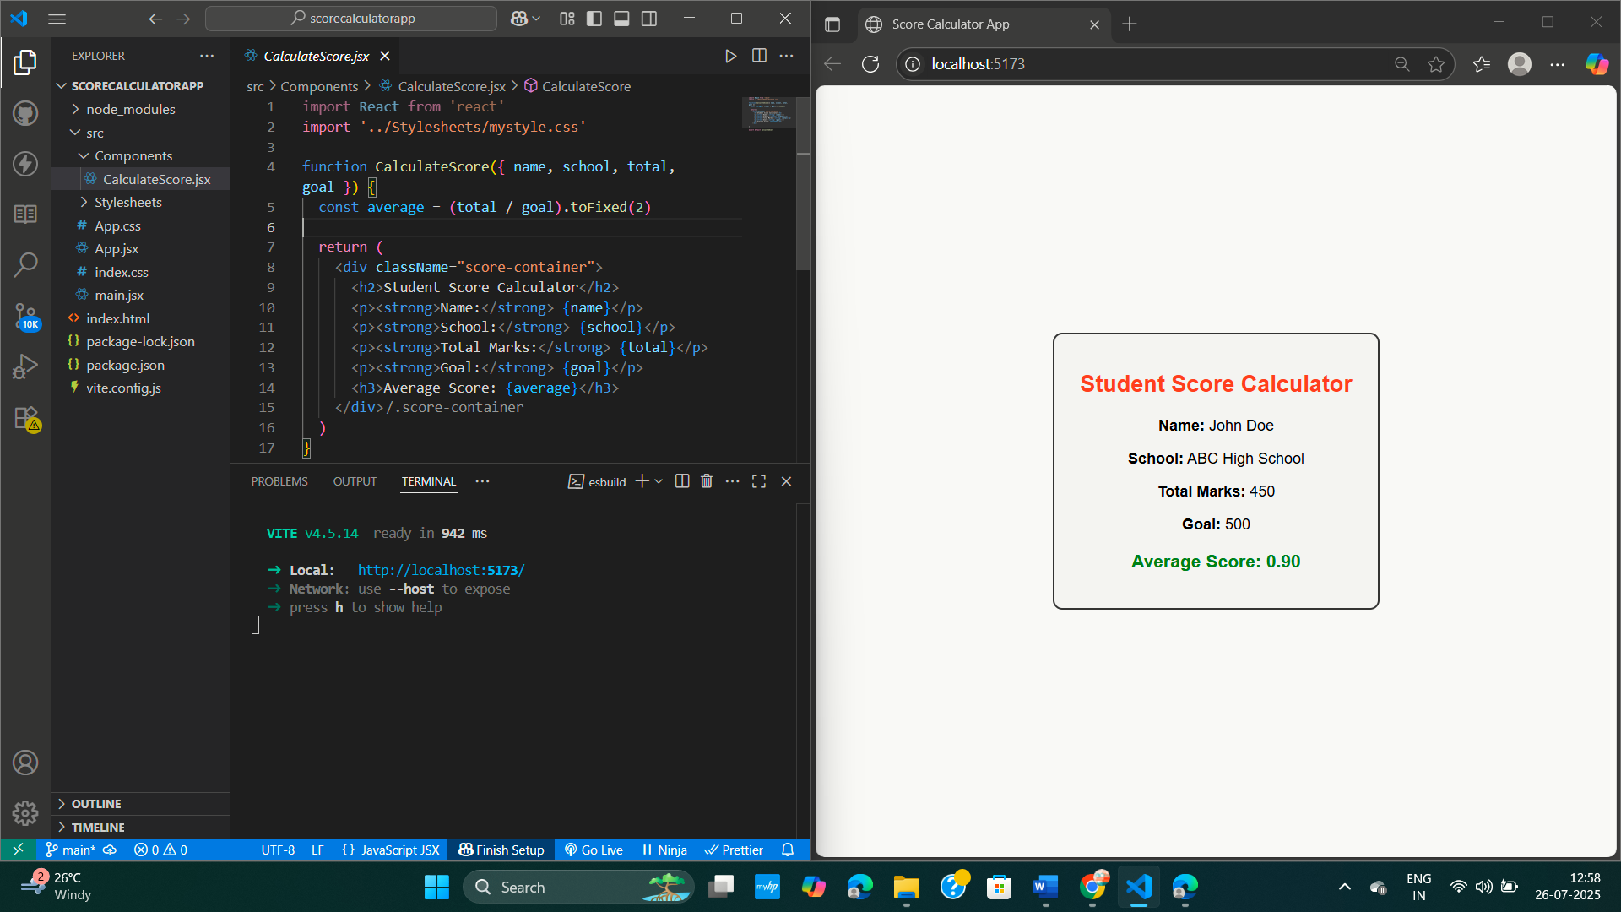

**Exercise 4 : BlogApp**

**PROBLEM STATEMENT :**

Create a new react application using create-react-app tool with the name as “blogapp”

**CODE :**

**App.js**

import React from 'react';

import './App.css';

import Posts from './Posts';

function App() {

  return (

    <div className="App">

      <Posts />

    </div>

  );

}

export default App;

**App.css**

.App {

  padding: 20px;

}

**index.css**

body {

  margin: 0;

  font-family: Arial, sans-serif;

  background: #f9f9f9;

}

**index.js**

import React from 'react';

import ReactDOM from 'react-dom/client';

import './index.css';

import App from './App';

const root = ReactDOM.createRoot(document.getElementById('root'));

root.render(

  <React.StrictMode>

    <App />

  </React.StrictMode>

);

**Post.js**

export default class Post {

  constructor(id, title, body) {

    this.id = id;

    this.title = title;

    this.body = body;

  }

}

**Posts.js**

import React, { Component } from "react";

import Post from "./Post";

class Posts extends Component {

  constructor(props) {

    super(props);

    // Initial state

    this.state = {

      posts: [],

      hasError: false,

    };

  }

  // Method to load meaningful blog posts (static data)

  loadPosts = () => {

    const postsArray = [

      new Post(

        1,

        "How to Prepare for Exams",

        "In this blog, we will explore tips to stay focused and organized during exam time."

      ),

      new Post(

        2,

        "Top 5 ReactJS Features You Should Know",

        "React is a powerful library with features like JSX, virtual DOM, and reusable components."

      ),

      new Post(

        3,

        "Healthy Morning Routines",

        "A healthy morning routine can improve productivity and mental health. Start with meditation and exercise."

      ),

      new Post(

        4,

        "Why Learn JavaScript?",

        "JavaScript is the language of the web. It helps you build dynamic websites and web apps."

      ),

      new Post(

        5,

        "Travel Essentials You Must Pack",

        "When traveling, don't forget essentials like chargers, toiletries, and important documents."

      ),

    ];

    this.setState({ posts: postsArray });

  };

  // componentDidMount() to load posts

  componentDidMount() {

    this.loadPosts();

  }

  // componentDidCatch() to catch errors

  componentDidCatch(error, info) {

    console.error("Error caught in componentDidCatch:", error);

    alert("Something went wrong while rendering posts!");

    this.setState({ hasError: true });

  }

  // Render method

  render() {

    if (this.state.hasError) {

      return <h2>Something went wrong!</h2>;

    }

    return (

      <div>

        <h1>Blog Posts</h1>

        {this.state.posts.map((post) => (

          <div key={post.id} style={{ marginBottom: "20px" }}>

            <h3>{post.title}</h3>

            <p>{post.body}</p>

            <hr />

          </div>

        ))}

      </div>

    );

  }

}

export default Posts;

**package.json**

{

  "name": "blogapp",

  "version": "1.0.0",

  "private": true,

  "dependencies": {

    "react": "^18.2.0",

    "react-dom": "^18.2.0",

    "react-scripts": "5.0.1"

  },

  "scripts": {

    "start": "react-scripts start",

    "build": "react-scripts build",

    "test": "react-scripts test",

    "eject": "react-scripts eject"

  },

  "eslintConfig": {

    "extends": ["react-app", "react-app/jest"]

  },

  "browserslist": {

    "production": [">0.2%", "not dead", "not op_mini all"],

    "development": ["last 1 chrome version", "last 1 firefox version", "last 1 safari version"]

  }}

**OUTPUT :**

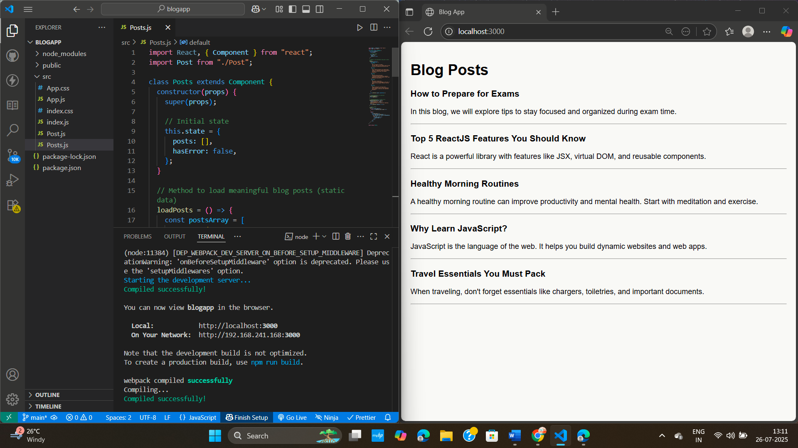

**Exercise 5 : Cohort Dashboard**

**PROBLEM STATEMENT :**

My Academy team at Cognizant want to create a dashboard containing the details of ongoing and completed cohorts. A react application is created which displays the detail of the cohorts using react component.

**CODE :**

**App.js**

import React from "react";

import CohortDetails from "./CohortDetails";

function App() {

  const cohorts = [

    {

      cohortName: "React Bootcamp",

      status: "ongoing",

      startDate: "2025-07-01",

      endDate: "2025-08-01",

    },

    {

      cohortName: "Node.js Masterclass",

      status: "completed",

      startDate: "2025-05-01",

      endDate: "2025-06-01",

    },

  ];

  return (

    <div style={{ padding: "20px" }}>

      <h2>Cohort Details</h2>

      {cohorts.map((c, index) => (

        <CohortDetails key={index} {...c} />

      ))}

    </div>

  );

}

export default App;

**App.css**

.App {

  text-align: center;

}

.App-logo {

  height: 40vmin;

  pointer-events: none;

}

@media (prefers-reduced-motion: no-preference) {

  .App-logo {

    animation: App-logo-spin infinite 20s linear;

  }

}

.App-header {

  background-color: #282c34;

  min-height: 100vh;

  display: flex;

  flex-direction: column;

  align-items: center;

  justify-content: center;

  font-size: calc(10px + 2vmin);

  color: white;

}

.App-link {

  color: #61dafb;

}

@keyframes App-logo-spin {

  from {

    transform: rotate(0deg);

  }

  to {

    transform: rotate(360deg);

  }

}

**App.test.js**

import { render, screen } from '@testing-library/react';

import App from './App';

test('renders learn react link', () => {

  render(<App />);

  const linkElement = screen.getByText(/learn react/i);

  expect(linkElement).toBeInTheDocument();

});

**CohortDetails.jsx**

import React from "react";

import styles from "./CohortDetails.module.css";

function CohortDetails({ cohortName, status, startDate, endDate }) {

  return (

    <div className={styles.box}>

      <h3 style={{ color: status === "ongoing" ? "green" : "blue" }}>

        {cohortName}

      </h3>

      <dl>

        <dt>Status:</dt>

        <dd>{status}</dd>

        <dt>Start Date:</dt>

        <dd>{startDate}</dd>

        <dt>End Date:</dt>

        <dd>{endDate}</dd>

      </dl>

    </div>

  );

}

export default CohortDetails;

**CohortDetails.module.css**

.box {

  width: 300px;

  display: inline-block;

  margin: 10px;

  padding: 10px 20px;

  border: 1px solid black;

  border-radius: 10px;

}

dt {

  font-weight: 500;}

**index.css**

body {

  margin: 0;

  font-family: -apple-system, BlinkMacSystemFont, 'Segoe UI', 'Roboto', 'Oxygen',

    'Ubuntu', 'Cantarell', 'Fira Sans', 'Droid Sans', 'Helvetica Neue',

    sans-serif;

  -webkit-font-smoothing: antialiased;

  -moz-osx-font-smoothing: grayscale;

}

code {

  font-family: source-code-pro, Menlo, Monaco, Consolas, 'Courier New',

    monospace;

}

**index.js**

import React from 'react';

import ReactDOM from 'react-dom/client';

import './index.css';

import App from './App';

import reportWebVitals from './reportWebVitals';

const root = ReactDOM.createRoot(document.getElementById('root'));

root.render(

  <React.StrictMode>

    <App />

  </React.StrictMode>

);

// If you want to start measuring performance in your app, pass a function

// to log results (for example: reportWebVitals(console.log))

// or send to an analytics endpoint. Learn more: https://bit.ly/CRA-vitals

reportWebVitals();

**package.json**

{

  "name": "cohorttracker",

  "version": "0.1.0",

  "private": true,

  "dependencies": {

    "@testing-library/dom": "^10.4.0",

    "@testing-library/jest-dom": "^6.6.3",

    "@testing-library/react": "^16.3.0",

    "@testing-library/user-event": "^13.5.0",

    "react": "^19.1.0",

    "react-dom": "^19.1.0",

    "react-scripts": "5.0.1",

    "web-vitals": "^2.1.4"

  },

  "scripts": {

    "start": "react-scripts start",

    "build": "react-scripts build",

    "test": "react-scripts test",

    "eject": "react-scripts eject"

  },

  "eslintConfig": {

    "extends": [

      "react-app",

      "react-app/jest"

    ]

  },

  "browserslist": {

    "production": [

      ">0.2%",

      "not dead",

      "not op_mini all"

    ],

    "development": [

      "last 1 chrome version",

      "last 1 firefox version",

      "last 1 safari version"

    ]

  }

}

**OUTPUT :**

